**Module 5 Assignment**

1. Here are the platforms available for Social Media Marketing :

* Facebook
* Twitter
* Instagram
* Email Marketing
* WhatsApp
* YouTube
* Reddit
* LinkedIn
* Pinterest

1. We can use different types of content for SMM which are as below :

* Videos ( Short and Long form Videos )
* Video Stories
* Written content like posts, blogs, articles etc.
* Images
* Shoppable content
* Influencing Content
* Educational Content
* Testimonials and Reviews
* Infographics
* Announcements
* Contests
* Holidays

**Videos:** Short-form video is the top trend marketers will be leveraging in 2023, and Social Media Trends Report found that it is the highest ROI format for social media marketing. With this in mind, creating short-form videos is a worthwhile investment, and some common examples are Instagram Reels, and YouTube shorts. Long-form video is also popular, but it doesn’t come close to the ROI of short-form. Live video gained steam during the pandemic, allowing people to participate in events remotely.

**Shoppable Content:** Shoppable social media content allows consumers to browse through products on your accounts, discover things they like, and even make a purchase without leaving the app. This is a valuable content type as social shopping is currently on the rise, and consumers are discovering new products and buying products on social media apps more than ever before.

**Educational Content**: Educational content shares helpful information with audiences that helps them reach their goals and meet their needs. Educational content can come in Infographics, videos, text-based posts, images — any of the content types we discussed in this post. People shares educational content through YouTube videos, where viewers can learn more about concepts of interest.

1. Social media platforms allow us to connect with other companies working in the same space or in industry that align with your goals. It also offers the opportunity to partner with influencers who can help promote your brand. Here are some common reasons as below :

* Widespread Audience
* Enhanced Brand Awareness
* Targeted Advertising
* Cost-Effective Marketing
* Engaging Content
* Customer Interaction and Feedback
* Analytics and Insights
* Competitive Edge

It is important to develop a well-defined social media strategy that aligns with your business goals, target audience, and brand identity. By leveraging the power of social media marketing, you can effectively promote your business, increase brand awareness, engage with customers, and drive growth.

1. SEO or Search Engine Optimization and Social Media Marketing are two distinct but interconnected strategies used in digital marketing. While they serve different purposes, they can complement each other to enhance overall online visibility and improve marketing efforts.

SEO focuses on optimizing websites and online content to improve their visibility in search engine results pages (SERPs) while Social Media Marketing involves using social media platforms (such as Facebook, Twitter, Instagram, LinkedIn) to promote products, services, or brands.

The **Relationship** between SEO and Social Media Marketing:

* **Increased Visibility and Reach:** Social media platforms provide an opportunity to reach a wider audience and increase brand visibility. By sharing content on social media, businesses can increase the likelihood of it being discovered and shared, leading to potential backlinks and mentions that can positively impact SEO.
* **Content Promotion and Link Building:** Social media platforms are ideal for promoting and distributing content. When content receives engagement and shares on social media, it can generate backlinks and increase referral traffic to the website, which can positively impact SEO.
* **Brand Signals and Social Proof:** Social media signals, such as likes, shares, and comments, can indirectly influence search engine rankings. These signals indicate that the content or brand is relevant and trustworthy, which search engines consider when ranking websites.
* **Keyword Insights and Audience Research:** Social media platforms offer valuable insights into audience behavior and interests. By analyzing social media data, businesses can identify popular topics, keywords, and trends. This information can guide their SEO strategy, enabling them to create content that aligns with audience interests and search intent.
* **Enhanced User Experience:** Both SEO and social media marketing contribute to improving the user experience. SEO focuses on optimizing website performance, loading speed, and mobile responsiveness, while social media marketing focuses on engaging and interacting with users. A positive user experience leads to higher engagement, longer website visits, and increased chances of conversions.

Overall, integrating SEO and social media marketing can lead to a synergistic effect, where the strengths of each strategy enhance the effectiveness of the other, resulting in improved online visibility, brand recognition, and website traffic.

1. Here are some points for http://www.designer2developer.com/ as below:

* Educational Guide content

We should include following points:

* Introduction
* User- Friendly Interface
* Bridging the Gap
* Tutorials and Guides
* Design Trends
* Real-World Projects
* Community Interaction
* Expert Contributors
* Subscriber Benefits
* Call to Action

Title: "Designer2Developer: Bridging the Gap in Web Development"

Description:

Welcome to Designer2Developer, your ultimate resource for mastering the art of web development! Whether you're a designer looking to expand your skill set or a developer seeking to enhance your design capabilities, this channel is the perfect destination for you. Our expert team is dedicated to bridging the gap between designers and developers, providing valuable insights, tutorials, and tips to create seamless and visually stunning websites. Join us as we explore the latest design trends, discuss front-end development techniques, delve into user experience optimization, and showcase real-world projects. Subscribe now to unlock the secrets of harmonizing design and development, and take your web creations to new heights with Designer2Developer!

1. Here are the tools that we can use as below:

* Facebook Ad Manager
* Facebook Business Manager
* Instagram Insights
* Facebook Analytics
* Facebook Pixel
* Facebook Business Suite
* Third Party tools

1. On platform like LinkedIn, we can expect various types of traffic such as :

* Professional Profiles
* Job Seekers
* Recruiters and Hiring Managers
* Business Pages
* Industry Professionals
* Content Creators
* Advertisers

It’s important to note that the type of traffic on LinkedIn can vary depending on your specific goals, connections, and interactions within the platform.

1. Email marketing is a digital marketing strategy that involves sending targeted messages or promotional materials to a group of people via email. It is a highly effective and widely used method for businesses and organizations to communicate with their audience, build relationships, promote products or services, and generate leads or sales. Here are some specific uses and benefits of email marketing:

* Direct Communication
* Relationship Building
* Promotions and Offers
* Lead Generation
* Customer Segmentation and Personalization
* Cost-Effective
* Measurable Results

Overall, email marketing is a versatile and powerful tool that businesses can use to reach their audience, foster relationships, drive engagement, and achieve their marketing objectives.

1. Email marketing can help you achieve several goals, depending on your specific objectives and target audience. Here are some common goals that can be accomplished through effective email marketing:

* Increasing Brand Awareness
* Driving Website Traffic
* Generating Leads
* Nurturing Customer Relationship
* Increasing Sales and Revenue
* Improving Customer Retention and Loyalty
* Gathering Customer Feedback
* Enhancing Customer Support

Remember, the effectiveness of email marketing depends on factors like list quality, segmentation, personalization, compelling content, and a strong call-to-action. It's important to regularly analyze your email campaign metrics and optimize your strategies to achieve the best results.

1. 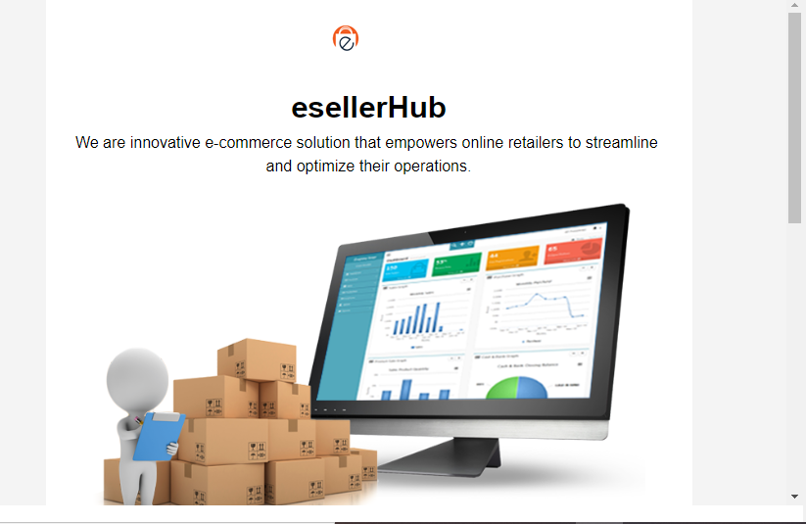

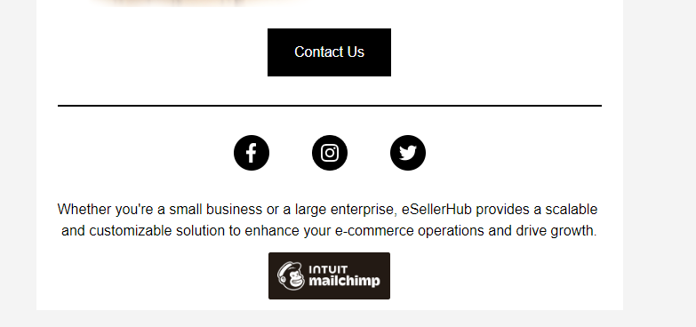

1. Affiliate marketing is a type of performance-based marketing in which a company or business rewards affiliates for each customer or sale generated through their marketing efforts. It is a mutually beneficial arrangement where the affiliate promotes the products or services of the company, and in return, they earn a commission for every successful referral or sale.

The process typically involves four key parties: the merchant (the company or business that sells the product or service), the affiliate (the individual or entity promoting the product or service), the customer (the person who makes a purchase), and the affiliate network or program (a platform that connects merchants with affiliates).

When a customer clicks on the affiliate's unique referral link or uses their code to make a purchase, the affiliate network or program tracks the referral and credits the affiliate for the sale. The affiliate then earns a predetermined commission or percentage of the sale value as a reward for their marketing efforts.

Affiliate marketing offers benefits to all parties involved. Merchants can increase their sales and reach a wider audience without investing heavily in marketing upfront. Affiliates have the opportunity to earn passive income by promoting products or services they believe in. Customers can discover new products or services through the recommendations of affiliates they trust.

It's important to note that the specific details and terms of affiliate marketing can vary. Commissions, tracking methods, payment schedules, and program policies can differ among different affiliate programs or networks.

1. There are several famous websites available for affiliate marketing. Here are some popular ones:

* Amazon Associates
* ClickBank
* Commission Junction
* ShareASale
* LinkShare
* eBay Partner Network
* Shopify Affiliate Program
* Udemy
* Etsy Affiliate Program
* Target Affiliates

These are just a few examples of famous websites available for affiliate marketing. There are many other affiliate networks and programs out there catering to various niches and industries.

1. There are numerous platforms available for affiliate marketing, each with its own unique features and benefits. Here are some popular platforms commonly used by affiliate marketers:

* Amazon Associates
* ShareASale
* CJ Affiliate
* ClickBank
* LinkShare
* eBay Partner Network
* Shopify Affiliate Program
* Awin
* Impact
* FlexOffers

It's important to research and evaluate different platforms to determine which one aligns best with your niche, target audience, and affiliate marketing goals.

1. 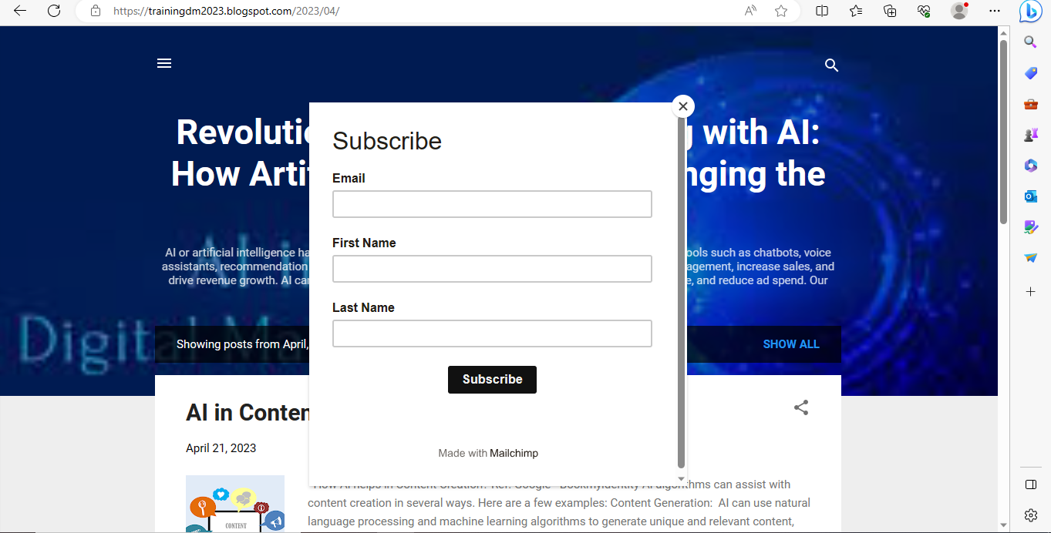

Subscription pop up added for Email marketing